IDEATIONPHASE
BRAINSTORM&IDEAPRIORITIZATION
TEAMID:NM2025TMID08074
PROJECT NAME: LEASE MANAGEMENT SYSTEM
This guided project demonstrates how to design and implement a Lease Management System within Salesforce. The system helps organizations manage properties, tenants, leases, and payments efficiently using Salesforce automation tools such as Flows, Validation Rules, Approval Processes, and Apex Triggers.
The objective of the project is to build a system that tracks lease agreements, automates rent reminders, and maintains accurate records of tenants and payments. Administrators and property managers can easily manage the complete lease lifecycle — from property listing to tenant management and rent collection — ensuring better transparency and automation.
The workflow includes creating custom objects for Property, Tenant, Lease, and Payment, along with necessary relationships and automations to ensure smooth lease operations.
Step 1: Team Gathering, Collaboration, and Selection of the Problem StatementLease Management Template Problem Statement:
Managing property leases manually can lead to missing payment deadlines, data inaccuracies, and lack of visibility for property owners and managers. To overcome these challenges, a centralized Salesforce-based Lease Management System is proposed to streamline operations and improve data accuracy.
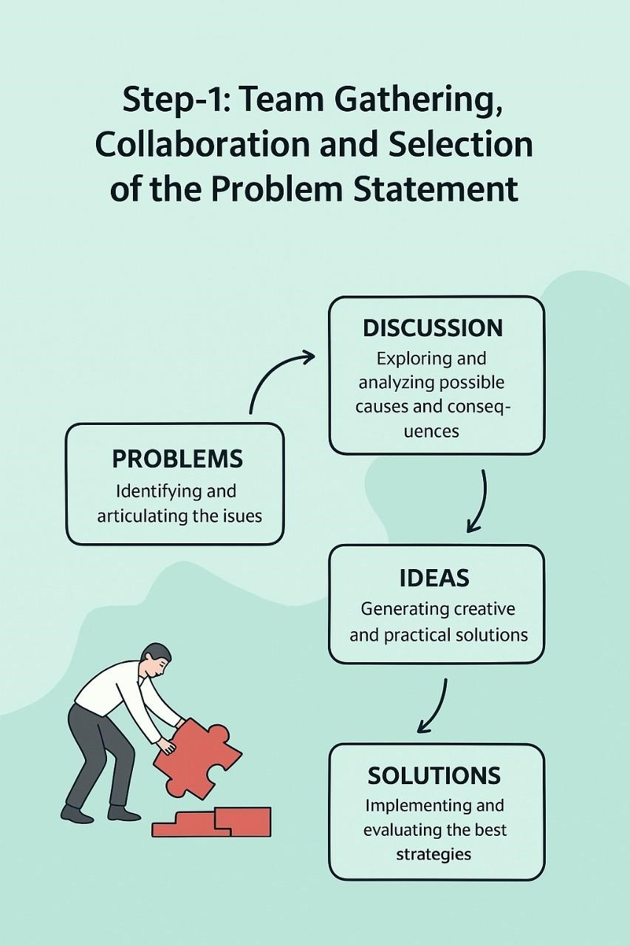
Step 2: Brainstorm, Idea Listing, and Grouping
Brainstorming: Team members freely share creative solutions related to property, tenant, lease, and payment management.
Idea Listing: All suggestions are documented — covering automation, validation rules, reports, and approval processes.
Grouping: Similar ideas are categorized under system design, automation, reporting, and user experience for easy prioritization.
Action Planning: The best ideas are selected, and clear tasks, roles, and timelines are set to guide project execution.

Step 3: Idea Prioritization
After brainstorming and grouping, the team evaluates each idea to identify which ones have the highest impact and feasibility for the Lease Management System.
During this stage, all ideas are analyzed based on criteria such as importance, ease of implementation, time required, and potential benefits. The most valuable and achievable ideas — like automating rent reminders, creating validation rules, and building dashboards — are given top priority.
This process helps the team focus on solutions that deliver maximum results with available resources, ensuring that development efforts are efficient and goal-oriented.
